UNIVERSITY OF CALIFORNIA, DAVIS


BERKELEY • DAVIS • IRVINE • LOS ANGELES • MERCED • RIVERSIDE • SAN DIEGO • SAN FRANCISCO SANTA BARBARA • SANTA CRUZ

Selection Committee
Graduate Group of Ecology
Davis, CA 95616

Re: Letter of support for Katherine Lauck
Dear Selection Committee,
I am writing enthusiastically support Katherine Lauck’s application for the Henry A. Jastro Research Award. If awarded, I commit to both assisting with budget administration/management, as well as support her throughout the duration of the project.
Please feel free to contact me with any questions or concerns.
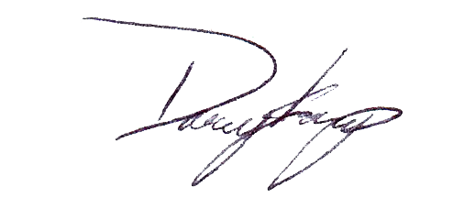
Sincerely,

Daniel S. Karp
Assistant Professor
Wildlife, Fish, and Conservation Biology
1088 Academic Surge
One Shields Avenue
Davis, CA 95616-8627
(530) 219-9868; dkarp@ucdavis.edu

